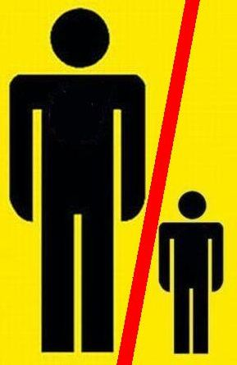

Press Release
(11th April 2006-For Immediate Release)
Ottawa Fathers Rights Activists intimidated and harassed by Ottawa Police

This writer Jeremy Swanson-Fathers and Men's Rights Activist of Ottawa was "visited" by the Ottawa police on Thursday 6th April at 3.00 pm in the afternoon. There was no warning or prior arrangement to talk with me. I did not know why I was targeted nor did I have anything to need to talk to the police about. I soon found out that the "visit" was linked to the Frank Mailly murder-suicide. I was not charged with anything nor am not implicated in, linked to or regarded as being any part of the crime. I did not know the Mailly family. However I was questioned for over 30 minutes. The police involved were two members of the detective squad by the names of Sergeant Jean Lamothe and Constable Andras Mozes.

To date I can not confirm nor am I aware that this visit may be part of any larger 'crack-down' on Fathers Rights Activists. However I do understand that at least one other Ottawa activist also received a "visit" by the Ottawa Police. My colleague and fellow activist Peter Roscoe was twice “graced” on the same day. The first visit for Peter was by 2 policemen and the second time by 4 members of the force. Although the police told the management of this building that they were acting legally they were not. The CEO of the YMCA where I reside has apologized to me personally and I have suggested that he communicate his concerns about police behaviour directly to them.

I did not give, offer or issue any information other than in reply to the questions I was asked and which affected me directly. I told them that Fathers, Men and Ottawa activists like all of the rest of you are only fighting for our and their constitutional and charter rights. And I told them why. I was asleep at the time of the visit and at a complete disadvantage. They banged on the door to wake me and then immediately ordered my room opened by the building management. They then entered my room without any invitation and engaged in interrogation. I was questioned at length. I was however allowed to change and join them in the TV room next door without aggravation. I was treated relatively politely and I was not threatened, treated roughly or discourteously. I was not assaulted in any way. And obviously I was not arrested. Clearly this was an intimidation exercise. Indeed it was a call to shut us up.

Activism sometimes gets attention as you can see. Other events around the country seem to suggest a general “reaction” by the Feminist Enemy and its allies. Pro-Father Radio Shows have been cancelled, trial judges seem to have been fixed for the trials of certain activists, and bailiffs in court have been ordered to throw out protestors. This is the time to fight on harder. We need to continue the struggle and intensify it-non-violently and legally but fighting for your rights-and the truth-nevertheless. Remember although the Family Courts do not respect our Charter Rights we are still guaranteed some rights under the Charter and that is the freedom of protest and assembly and association-among many others. There are no indications that these might be denied us. At least they have not been denied yet. The way things are going it might not be far off. Activists are leaving notes with friends so that families and others can be contacted in the event of a midnight arrest.

-30-

.NB: Jeremy Swanson is an activist not by choice but by necessity. Like thousands of Canadian Men and Fathers he has suffered greatly under Canadian “Family Law”. He regards the current and past Liberal Policies regarding Divorce and Custody as not only being draconian and biased but as a return to social fascism. Besides the objective of changing the laws of custody and divorce he seeks the advent of non-confrontational divorce, mediation as an essential and imperative part of divorce, the removal of lawyers from issues of divorce and the automatic granting of Equal shared parenting. Jeremy is an avowed supporter of the principles, aims, and actions of the militant father’s rights group Fathers for Justice (F4J Canada

