Community Information Meeting

Hosted by Citizens’ Accountability Group of Grey-Bruce
affiliated with http://www.accountabilitycircle.org

Dealing with the Children’s Aid Society and the Family Courts
Location: Knox United Church – Thursday, November 19, 2009 – 7:00 pm

Every year in Ontario, thousands of Ontario children and their families are adversely affected and in many cases torn apart as a result of the draconian policies and procedures of the family courts and Children’s Aid Societies.

On Thursday, November 19, 2009 concerned citizens in the Owen Sound, Ontario area will be hosting a public awareness meeting to provide help and information to families in the community being adversely affected by our family justice system and by the Children’s Aid Society (CAS).
A guest speaker from Canada Court Watch will be giving a presentation to the audience about the problems with the courts and the Children’s Aid Society and provide helpful information. A question and answer session will follow the presentation. For information about Canada Court Watch visit their webpage at:
http://www.canadacourtwatch.com
If you are a parent or a child who has been affected and would like to learn more about how to deal with the courts or with the CAS, then you should attend this meeting.
If you are a citizen who would like to assist others in the community to bring greater accountability and transparency to our family justice and child protection systems, then we urge you to attend this event. This meeting will be a good opportunity for individuals and families to network with others who have been similarly affected or who have similar interests.
Meeting location details
7:00 pm at Knox United Chursh, 890 4th Ave E. Owen Sound (on the corner of 9th St. and 4th Ave.) Doors open at 6:30 pm. There is plenty of free parking at the church. Donations would be appreciated to help cover costs.

Pre-event meeting
If you are coming from out of town and plan to arrive early, a pre meeting event dinner gathering is planned for those wishing to network with others before the general meeting. Anyone interested in attending, call organizers for details.
For further information
For further information or to ensure that your name is on the list of participants then contact one of the organizers listed below:

Esther - (226) 668-0958 or
444missesther@gmail.com

Mike - michael_d_e@hotmail.com

Map of meeting location
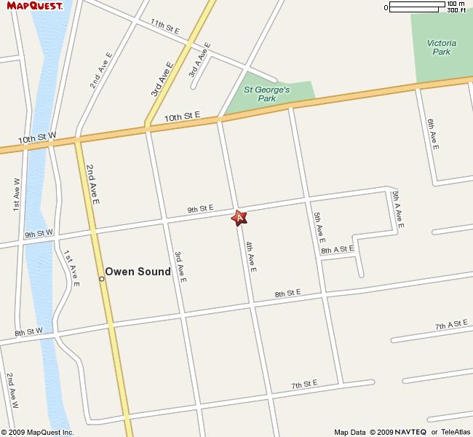

Map showing public meeting location
Knox United Church is located in the heart of Owen Sound. For specific driving directions from a particular location obtain driving directions from either Google Maps or Mapquest.

