TOWN HALL MEETINGS
Critical discussions are taking place in Orangeville
About the Dufferin Children’s Aid Society
the Ontario Family Court and Child Welfare System
Every Wednesday beginning April 2nd from 8:00 to 9:00 p.m.
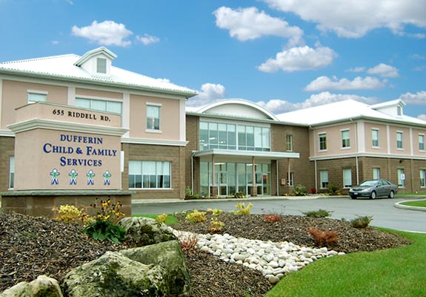  Who else should attend?  - Social Workers and Social Service Workers  - Child and Youth Workers  - Mental Health Workers and Therapists  - Teachers and Principals  - Advocates for Child and Youth  - Elected Government Representatives  - Orangeville Town Council Elected Representatives  - Advocates for parents and children  - Doctors, Nurses, Lawyers, Judges | Who should attend?  - Parents and Grandparents who have had DCAFS (Children’s Aid) involved with your family  - Youth coming out of the Child Protection System over the age of 16; young parents; single parents  - Parents with low income and receiving OW or ODSP  - Youth in foster homes and group homes (voluntary or involuntary)  - Parents whose children have been Apprehended by Child Protection Workers  - Parents with cases in the Ontario Family Courts with the CAS  - If access to your child has been denied or minimized  - If your complaints are not being heard  - If your parental rights have been stripped from you
For More Information and Location go onto the Facebook page Town Hall Meetings Dufferin Children’s Aid Society
Phone: 519-278-4060 or Email: rhondann@rogers.com
Hosted by Rhonda Nordlander Social Justice Advocate and Social Change Agent

